Homework Assignment 4

Zach Kushnir - 4367785

1- Regularization

1. MATLAB
2. Output:

Data size =

1001 501

1. I would suggest a value of lambda of 0.007 because it yields the smallest difference in error between the training and testing data.

ps4-1-c.png

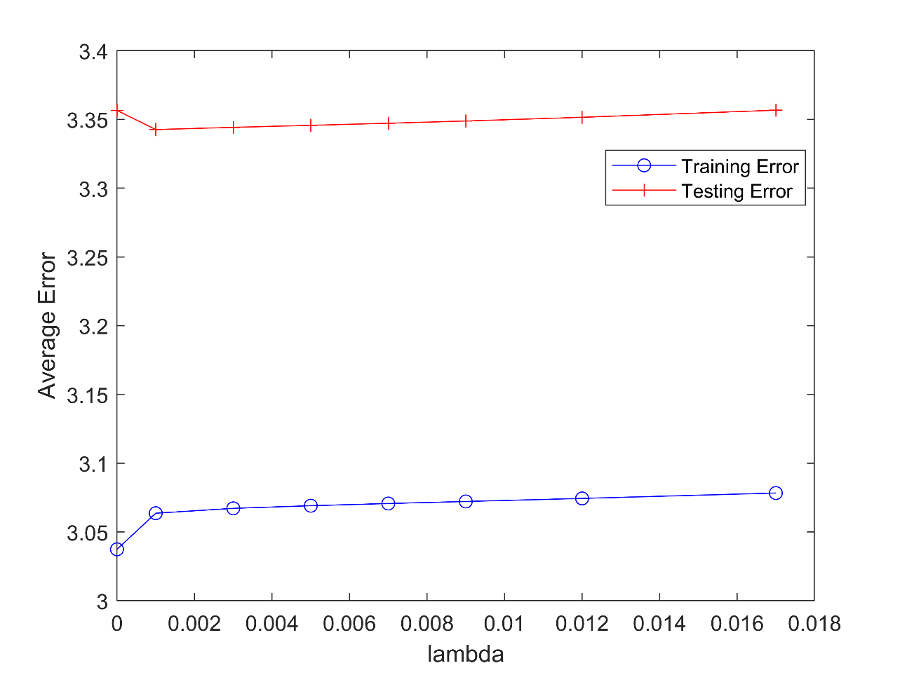

2- KNN – Effect of K

1. For this problem, I would suggest a value of K of 9 because it yields the greatest average accuracy. This value is not robust to any other problem because it largely depends on this particular dataset and would vary with another dataset.

ps4-2-a.png

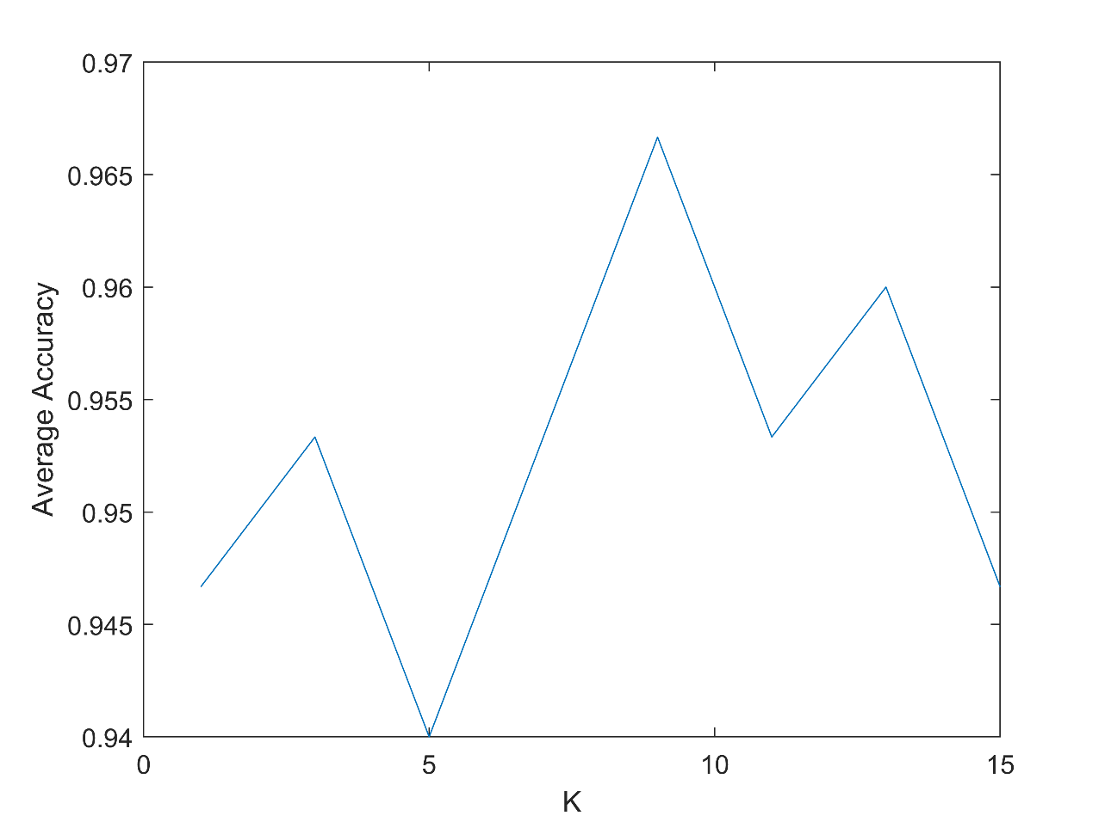

3- One-vs-all

1. MATLAB
2. Output:

|  |  |
| --- | --- |
| Training Accuracy | 84% |
| Testing Accuracy | 93.6% |